Skyline High Resolution Metabolomics

The Skyline Targeted Mass Spectrometry Environment provides informative visual displays of the raw mass spectrometer data you import into your Skyline documents. Originally developed for proteomics use, Skyline has been extended to work with generalized molecules. This tutorial explores using Skyline for targeted quantification of small molecules using high resolution mass spectra.

In this tutorial, you will learn about Quantification of Polyunsaturated Fatty Acids in Plasma using NIST SRM-1950 as a single-point external calibrant, used along with stable-isotope labeled internal standards.

You will explore:

* Use of a molecular formula and adduct to assign a precursor accurate mass.
* Analysis of high resolution accurate mass precursor quantification data in Skyline.
* Quantification using single-point external calibration with SIL internal standards and surrogate standards.
* Use of a Concentration Multiplier to adjust the calibration range for each analyte.

Skyline aims to provide a vendor-neutral platform for targeted quantitative mass spectrometry research. It can import raw data from the instrument vendors Agilent, SCIEX, Bruker, Shimadzu, Thermo-Scientific, and Waters. The ability to import data across various instrument platforms facilitates cross-instrument comparisons and multi-site studies. This remains equally true in using it to target small molecules, as it has been for years in the field of proteomics.

If you have not already looked at the “[Skyline Small Molecule Targets](https://skyline.ms/tutorial_small_molecule.url)” tutorial you should do so now, in order to pick up a few basics about how Skyline works with small molecule descriptions including chemical formulas and adducts.

# Getting Started

To start this tutorial, download the following ZIP file:

<https://skyline.ms/tutorials/HiResMetabolomics.zip>

Extract the files in it to a folder on your computer, like:

C:\Users\bspratt\Documents

This will create a new folder:

C:\Users\bspratt\Documents\HiResMetabolomics

It will contain all the files necessary for this tutorial.

If you have been using Skyline prior to starting this tutorial, it is a good idea to revert Skyline to its default settings. To do so:

* Start Skyline.
* On the **Start Page,** click **Blank Document** which looks like this:

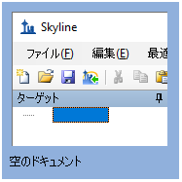

* On the **Settings** menu, click **Default.**
* Click **No** on the form asking if you want to save the current settings.

The document settings in this instance of Skyline have now been reset to the default.

Since this tutorial covers a small molecule topic, you can choose the molecule interface by doing the following:

* Click the user interface control in the upper right-hand corner of the Skyline window, and click **Molecule interface** which looks like this:

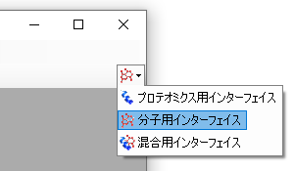

Skyline is operating in molecule mode which is displayed by the molecule icon  in the upper right-hand corner of the Skyline window. Its original proteomics menus and controls are now hidden, allowing you to focus on small molecule analysis.

# Importing a Molecule Transition List into a Skyline Document

To add a set of target transitions for the small molecules in this experiment, do the following:

* If you are an Excel user, open the provided PUFA_TransitionList.xlsx file. Otherwise, you can open the CSV version PUFA_TransitionList.csv in any text editor.
* Copy the contents of the transition list to the clipboard, including the header row, with the column names in it.
* On the Skyline **Edit** menu, choose **Insert** and click **Transition List**.

Skyline will show the **Insert Transition List** form, looking something like this:

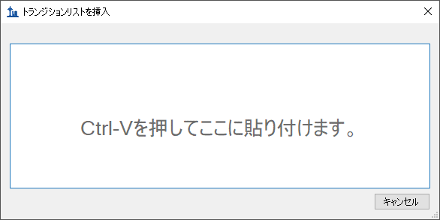

* Press **Ctrl-V** to paste the information you placed on the clipboard into Skyline.

Skyline will show the **Import Transition List: Identify Columns** form:

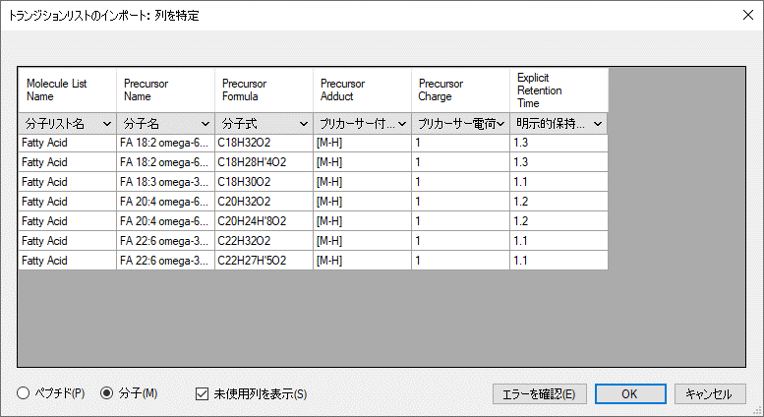

Make sure that the **Molecules** radio button is selected.

* Press the **Check For Errors** button.

Skyline reports that there are inconsistencies in the data: the precursor adducts are all [M-H] but the precursor charges are declared as +1.

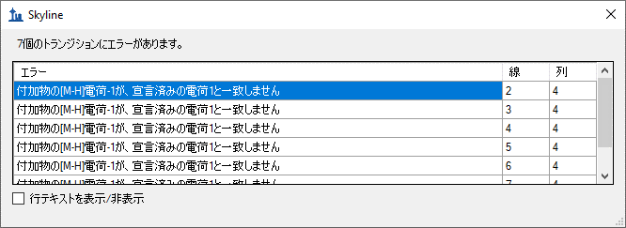

This is easy to correct:

* Click the **OK** button in the error report form.
* Click the dropdown control in the **Precursor Charge** and choose “Ignore Column”.

The precursor adduct is all the information that is needed.

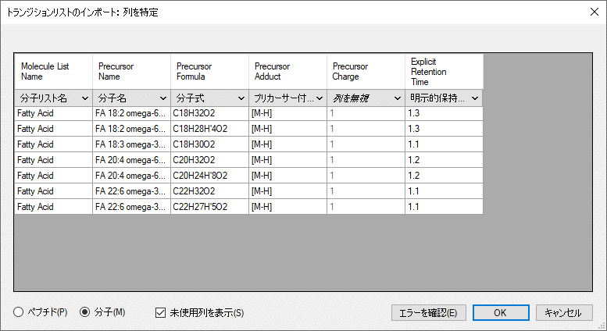

Notice that the first two entries are a heavy/light labeled pair based on having the same name and formulas that differ only in isotopic labeling (four of the hydrogens are replaced by Deuterium in the second formula). Skyline will recognize these as heavy/light labeled pairs.

* Click the **OK** button.

Skyline imports the transition list and shows the result in the **Targets** window.

* On the Skyline **Edit** menu, choose **Expand All** and click **Precursors**.

Your Skyline window should now look like this, displaying a tree of polyunsaturated fatty acids, along with their stable-isotope internal standards (as applicable):

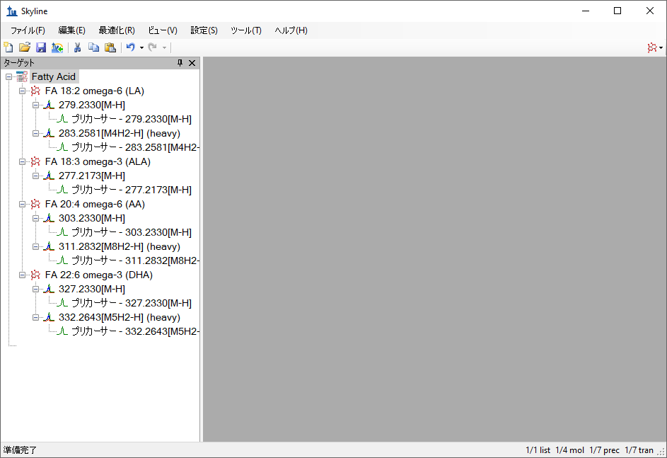

Note that for the molecules with a heavy labeled precursor, the label is expressed as part of the adduct description for the heavy variant. The “[M4H2-H]” adduct tells you that four hydrogen atoms in the molecule are replaced by deuterium or H2 (“M4H2”) and that it is ionized by a proton loss (“-H”).

**Adding Isotopic Peaks**

When Skyline reads a small molecule transition list it adds only the precursors and fragments explicitly included in the transition list. Each item added to the document is created with **Auto-select** turned off so that any settings changes do not cause any surprise changes to the number of molecules, precursors or transitions in the document.

In this tutorial, though, we *do* want settings changes to cause transitions to be added to the document – specifically we want Skyline to add the M+1 precursor isotopes. So. now you will review the transition settings and make some changes including those needed to add M+1 isotope peak precursors transitions to the Skyline document. To do this, perform the following steps:

* On the **Settings** menu, click **Transition Settings**.
* Click the **Filter** tab.
* In the **Ion types** field, enter “p”.

The **Transitions Settings** form should look like this:

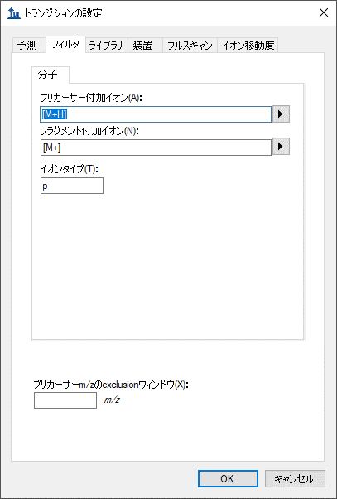

|  |
| --- |
| NOTE: The “p” setting in **Ion Types** on the **Filter** tab means you are interested in **p**recursor ion transitions. This Skyline document contains only precursor transitions, but if there were also **f**ragment transitions in the input transition list we would set this to “**f, p**”. |

* Click to the **Full-Scan** tab in the **Transitions Settings** form.
* Set the **Isotope peaks included** field to “Count**”.**
* In the **Peaks** field, enter “2”.
* Set the **Precursor mass analyzer** field to “Orbitrap**”.**
* Set the **Resolving power** field to “70,000”, **At** “200” *m/z.*
* In thesection **Retention time filtering** section**,** choose **Include all matching scans**.

The **Transitions Settings** form should look like this:   
  
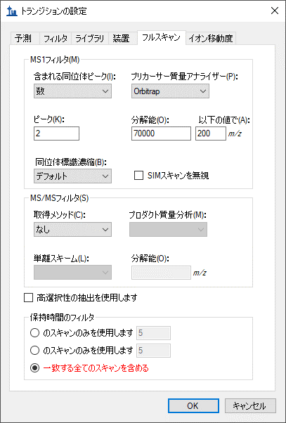

* Click the **OK** button.

# Auto-select Transitions

The **Isotope peaks included** and **Peaks** fields tell Skyline to use the chemical formulas provided in the input transition list to add a precursor transition representing the M+1 isotope peak in addition to the monoisotopic peak. But Skyline still hasn’t done that yet – why?

As mentioned earlier, when Skyline reads a small molecule transition list it adds only the precursors and fragments explicitly included in the transition list, and each is added to the document with **Auto-select** turned off.

So we now want to turn on **Auto-select** for transitions. This could be done one by one in the Targets window, but doing them all at once is easiest:

* On the **Refine** menu, click **Advanced…**

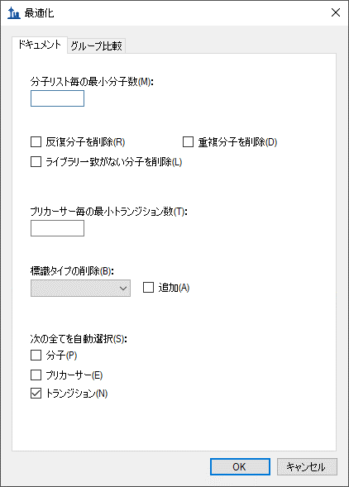

* Check the **Transitions** box **under Auto-select all**
* Click the **OK** button.

With the addition of M+1 precursor transitions, the number of transitions in the document changes from 7 to 14.

# Surrogate Standards

You will notice that ALA (alpha-linoleic acid) does not have a heavy-labeled precursor. Instead, it will be assigned a different stable-isotope labeled molecule as its surrogate standard. In this case d5-DHA will be used because it is the closest in retention time. To prepare for this association, do the following:

* Right-click the “DHA” target, choose **Set Standard Type**, and click **Surrogate Standard**.

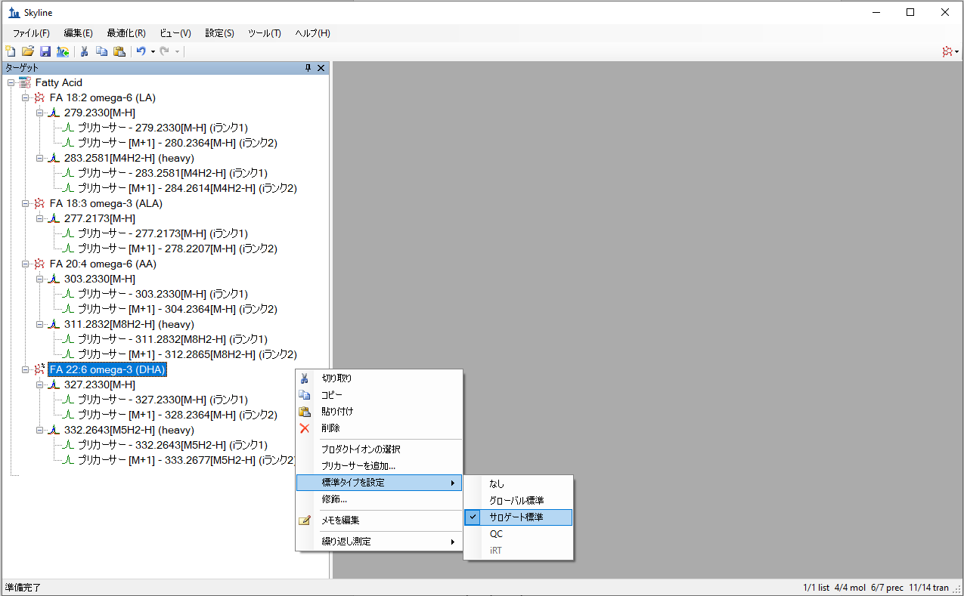

Now the experimental mass spectrometer results can be imported.

# Importing Mass Spectrometer Runs

Perform the following steps:

* On the **File** menu, click **Save**. (Ctrl-S)
* Save this document as “SM_HiRes_v1.sky” in the tutorial folder you created.
* On the **File** menu, choose **Import** and click **Results**.
* In the **Import Results** form, choose **Import single-injection replicates in files**.
* In the **Files to import simultaneously** dropdown list at the bottom of the form, click **Many** which will provide the best import performance.
* Click the **OK** button.
* Select all 16 raw data folders in the tutorial folder by clicking the first listed and then holding down the Shift key and clicking the last.

The **Import Results Files** form should look like this:

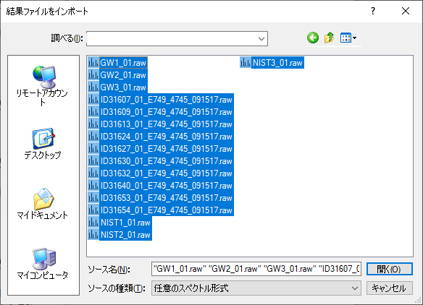

* Click the **Open** button.

The files should import within 30 seconds or so, leaving your Skyline window looking like this:

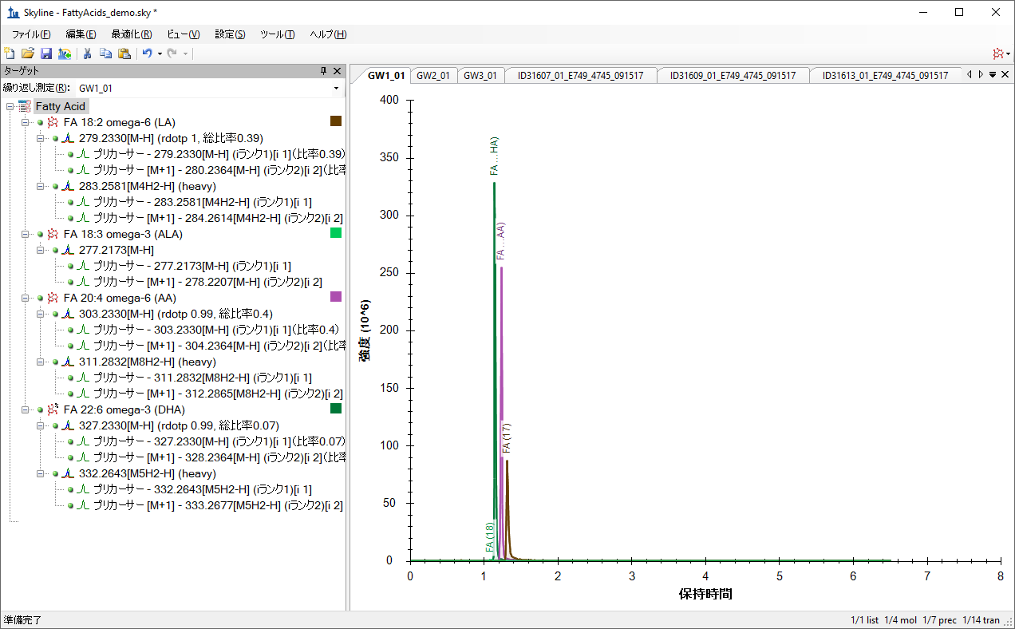

To take advantage of the Skyline summary graphs for viewing individual targets, do the following:

* On the **View** menu, choose **Peak Areas** and click **Replicate Comparison**.
* On the **View** menu, choose **Retention Times** and click **Replicate Comparison**.
* Click and drag these views to dock them above the chromatogram graphs.
* On the **View** menu, choose **Document Grid.**
* In the **Document Grid** view, click the **Reports** menu, and then click **Peptide Quantification**.
* Click and drag the **Document Grid** view and dock it next to the chromatogram graphs.

The Skyline window should now look like this:

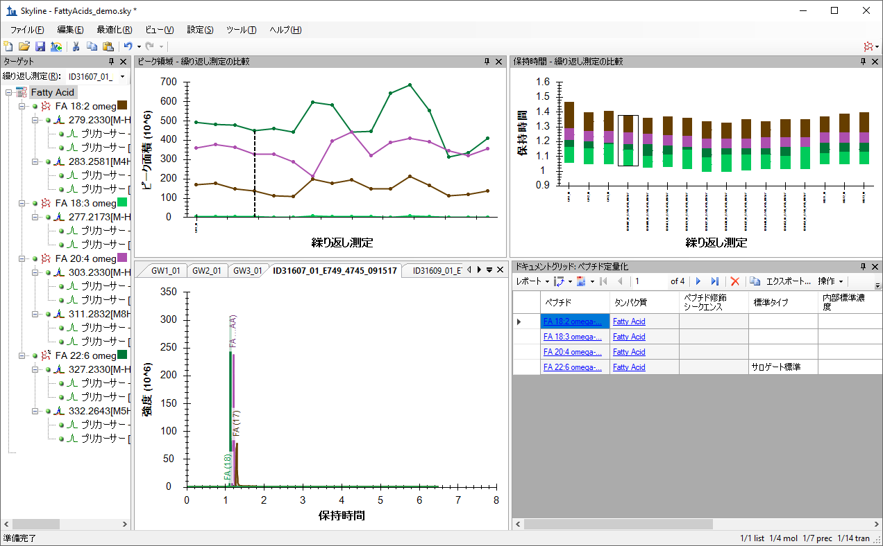

# Checking Peak Integration

Looking at the **Retention Times – Replicate Comparison** window, you can see by the lack of outliers that Skyline did not have any problems with peak integration.

# Preparing for ‘Single Point Quantification’

Next, follow these steps to prepare Skyline to produce calibrated quantitative values for the targeted molecules based on an external single-point calibration run:

* On the **Settings** Menu, click **Molecule Settings.**
* Click the **Quantification** tab.
* In the **Regression fit** field, select “Linear though zero”.
* In the **Normalization method**, select “Ratio to Heavy**”.**
* Leave the **Regression weighting** field set to “None”.
* Leave the **MS level** field set to “All”**.**
* In the **Units** field enter “uM”.

The **Molecule Settings** form should look like this:

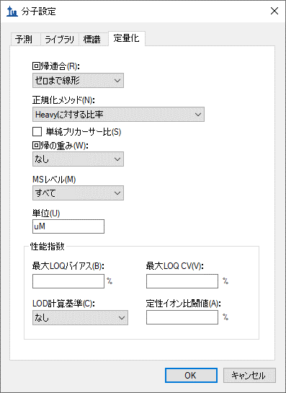

* Click the **OK** button**.**

Return to the **Document Grid** view and do the following:

* Click the **Reports** menu, and then click **Replicates**.

To establish the role of each of the samples (replicates) in the study, as a standard, an unknown, or a quality control run, edit the Sample Type and Analyte Concentration cells for each row as necessary so the grid looks like this:

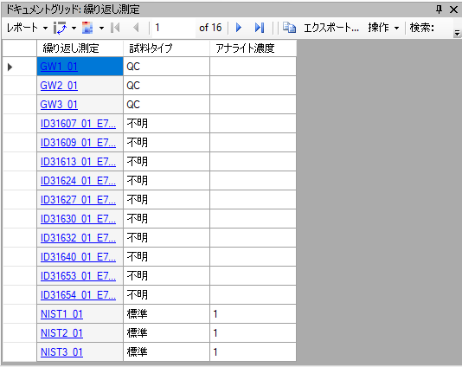

In this situation, the concentration given for the NIST sample (NIST-SRM-1950) is entered as “1”, since all analytes have a different concentration. Think of this as establishing your standard as “One NIST Unit”. Therefore, in the next step, the concentration multipliers will each be given as the actual concentration of the analyte in the NIST SRM-1950 in order to adjust the target concentration of those analytes to their respective reference values.

* In the **Document Grid**, click on the **Reports** menu and then click **Peptide Quantification**.
* Set the Concentration Multiplier and Normalization Method cells for each target as shown below.

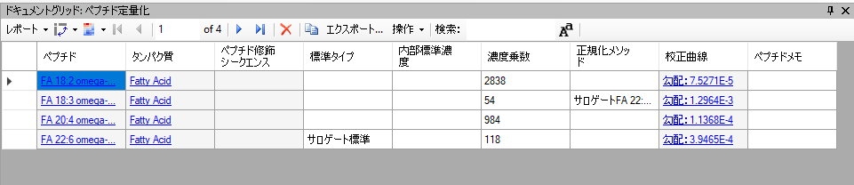

The default normalization method is “Ratio to Heavy” when using stable-isotope internal standards, but you need to set the “FA 18:3” analyte to use the previously-defined surrogate standard as the denominator in the analyte to standard ratio.

# Inspecting the Calibration Curves

Each entry in the Calibration Curve column is a clickable link that shows and activates the **Calibration Curve** view for the molecule in that row.

* Click on the calibration curve link for “FA 18:2”

The **Calibration Curve** view will appear looking like this:

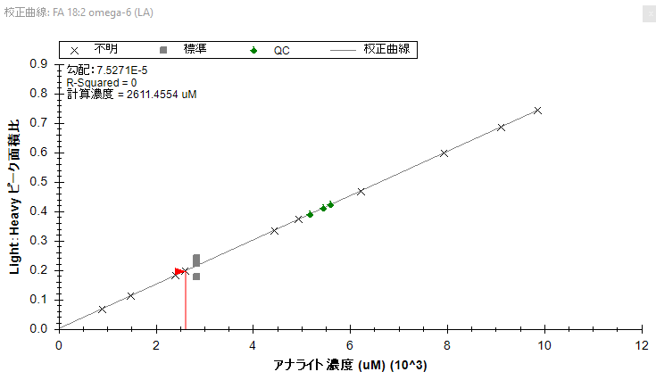

Note that the calibration curve by default has an intercept of 0, as defined by the method of quantification (**Settings** menu, **Molecule Settings**, **Quantification** tab). Using a single concentration in the external calibration runs defines a “single point” at that concentration and the average Light:Heavy ratio of the measured runs. This point and the zero intercept, thus, define the linear equation used to calibrate all other runs. The **Calibration Curve** graph shows the Unknown and Quality Control points plotted on that line, because you did not enter known concentrations for them. In some experiments, quality control runs are used where the concentrations are known, but in this case the quality control runs are technical replicates of a sample pooled from the unknown samples.

The **Document Grid** or **Report Grid** can be used to export quantitative data (in micromolar) for each sample analyzed.

# Conclusion

In this tutorial, you have learned how to create a Skyline document that targets small molecules specified as precursor ion chemical formulas and adducts. You imported a multi-replicate data set collected on a Thermo Q Exactive Orbitrap mass spectrometer for a set of plasma samples, , and saw how many existing Skyline features created initially for targeted proteomics use can now be applied to small molecule data. You applied external single-point calibration to derive micromolar values for each analyte in each run where the concentration was unknown.